***Student Supply List***

***2025-2026***

**GRADE K**

Regular backpack- 9x12 or larger

Fiscar scissors- pointed end, small-kid size

Plastic school supply box- reg.size (not long)

24 ct. Twistable crayola crayons- basic colors, no glitter

1- 10 pack Crayola wide washable markers- primary colors

12 purple Elmers glue sticks-small

1 pack black fine tip whiteboard markers

Optional:

Plug-in headphones

Pack of 3x5 index cards

Kid-sized spill proof water bottle

2 boxes of tissues

**GRADES 1-2**

PE shoes  (do not have to be brand new, just clean shoes)

Paint Shirt (large shirt to cover clothes while painting)

Plug in headphones (not bluetooth/wireless)

1 pack of Ticonderoga pencils (no mechanical pencils)

3 packs of glue sticks

Scissors (Fiscar w/pointed tip, labeled with name)

Pencil Box (regular size, not long, labeled with name)

1 pack of 3x5 index cards

Kids size spill proof water bottle (closable)

Backpack (9x12 or larger, labeled with name)

Tissues

1 pack of black, fine tip, whiteboard markers

2 yellow highlighters

1 pack twistable crayons

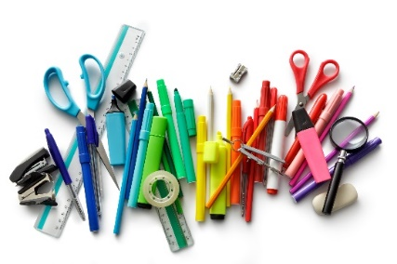

**GRADES 3-4**

Backpack or bookbag

1 supply/pencil box or pouch

1 spiral notebook

1 composition book

Scissors, pointed end

Pocket pencil sharpener

Crayons, 24 pack (twistable preferred)

Headphones (optional)

Gym shoes

1 box facial tissues

**GRADES 5-6**

24 Pencils- #2 Ticonderoga brand OR mechanical pencils

Pencil box

Colored pencils

Handheld pencil sharpener

1 pack of red pens

3 packages of notebook paper

2 spiral notebooks

2 pack thin sharpies

Calculator

2 in. binder (heavy duty so they last all year)

8 tab dividers for binder

4 glue sticks

Scissors

Gym shoes - Indoor shoes, clean soles

1 box of tissues

Optional:

Headphones- the school does supply but some students want their own

1 pack of highlighters (multi color)

**GRADES 7-8**

1 package of ink pens (not-erasable)

1 package of multi-colored colored pens, pencils or crayons

1 2” binder, 3-ring large flat laying

15 Page Dividers and a large package of page protectors

1 Single Subject spiral notebook or composition book

1 glue stick

Scissors and a Calculator

Gym shoes and PE clothes

1 large box of tissues

Pack of 3x5 index cards

Sharpies – 2 regular point and 2 fine point, black

Optional - Personal Headphones – NOT Bluetooth/wireless